SURVIVAL OR EXTINCTION

by
KEVIN MUGUR GALALAE

PART SEVEN
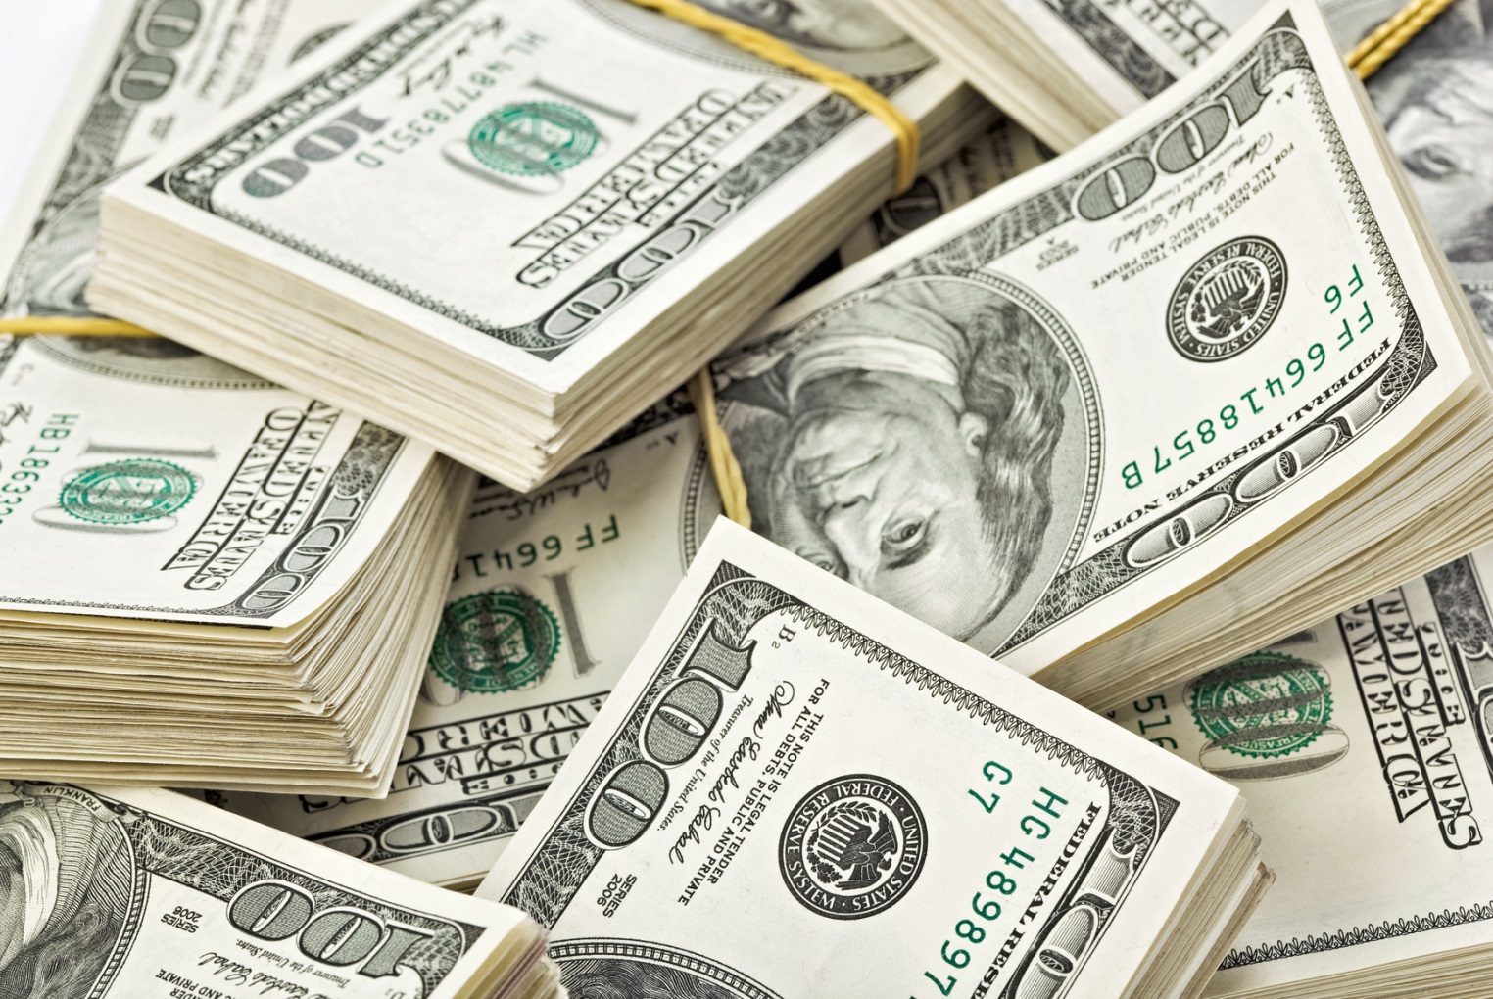
POWER OF MONEY

(PART ONE: LIFE OR DEATH; PART TWO: FOLLOW THE MONEY; PART THREE: NEED NOT GREED; PART FOUR: TAMING THE WOLVES; PART FIVE: DISCARD ME NOT; PART SIX: HEAD AND HAND)

Don’t be intimidated by the economic content of this article, about which you think you know little. Economists hide very simple concepts behind fancy words to obscure the facts and monopolize knowledge so as to be able to advance plans that if known would cause too much disagreement and squabbling and prevent their implementation. Lesser minds among economists also hide behind professional jargon to bask in their self-importance as well as to lend an esoteric dimension to their otherwise dry and boring field of knowledge, which requires merely average intelligence to master.
Bear with me as I spoil their secrets and shed light on the economic manipulations of our lives and society; manipulations that are intended for good ends and not diabolical ones as it is often believed.
One myth I will shatter in this article is that bankers are in control of the world. I will instead show that the banking system is beholden to political decision makers, who are using the power of money, or monetary coercion, to advance by proxy the ancient dream of a united world, which is a political goal and a worthy one. Having learned from history that international peace and security cannot be gained by conquest, thus by military means, policy makers since the end of World War II have employed fiscal means to force the world into peaceful cooperation and coexistence. Monetary coercion has replaced military force as the method by which to secure global peace and prosperity, which are the fundamental prerequisites of a one world order.
Let us get started by going back in time when the political decision was made to put in place a set of rules and the institutions necessary to enforce them to ensure that nations refrain from taking what is not rightfully theirs and instead engage in peaceful trade with other nations to obtain the natural resources they need to industrialize and prosper. That time is 1944 and the place is Bretton Woods, New Hampshire.
At Bretton Woods, a fully negotiated monetary order was set in place to govern commercial and financial relations among the 44 independent nation-states that chose to participate, and which obligated each country to adopt a monetary policy that tied every currency to the US dollar, maintain the exchange rates, and empower the International Monetary Fund (IMF), a newly formed institution, to bridge temporary imbalances of payments.
By this political decision order was made from the chaos that previously reigned on the international arena with respect to how nations access vital resources found outside their territories. By ensuring that everyone pays for the resources they need rather than trying to take them by force, as was previously the case and that led to two world wars, peace was secured. To be able to pay for resources rather than take them by force, a system was created to recognize the value of each national currency and to facilitate trade between nations by allowing international financial transactions to take place as orderly and smoothly as national financial transactions. Bretton Woods was in other words the first and most important step towards an integrated global economy.
The Bretton Woods order gave the US dollar a central role, as the currency of global trade. To engage in international trade every nation needed henceforth to buy dollars before it could buy goods, resources or services from other nations. The US dollar therefore became the reserve currency of choice and the United States needed to print more money than any other nation on earth in order to satisfy the global demand for its dollars. This proved to be a problem because every dollar issued had to be backed up with gold, as demanded by the so-called “gold exchange standard” that was also agreed upon at Bretton Woods. According to this arrangement, countries fixed their exchange rates relative to the US dollar and central banks could exchange their dollar holdings into gold at the official exchange rate of $35 per ounce, so that all currencies pegged to the dollar had a fixed value in terms of gold. Gold therefore was the standard by which to measure the value of money and by which to ensure that the value is not diluted.
In time, however, the burden on America to back up with gold the vast amounts of dollars it issued in order to facilitate global trade became too great and the US was forced to abandon the gold standard. Henceforth currencies became detached from gold, thus from any fixed asset. Such currencies are known as “fiat money”, which means money with no intrinsic value. All currencies in the world today are fiat money.
There is much talk nowadays in the alternative media and even among economists about a return to the gold standard and the evil machinations of bankers who usurped the value of the dollar and emptied the vaults of the Federal Reserve of gold bullion. But such talk is complete nonsense nurtured to detract people from understanding the world around them and to blame imagined culprits for the hardship we are going through as a result of being in the midst of the greatest transition in human history, a transition from national self-determination to global government and from national economies to a global economy.
The notion that fiat currencies can be abandoned for a return to the gold standard is retarded for the simple reason that we would need the gold of three planets to back up the value of all currencies, which in turn represent the value of each nation’s entire economic activity. Fiat currencies came into being in the early 1970s for the very reason that there was insufficient gold to ensure the convertibility of the Deutsch Mark and U.S. Dollar (then the primary reserve currencies of the world) to gold. No single precious metal is available in quantities large enough to be equivalent in value to the entire economic output of the world. This shortage of metals is even forcing nations to abandon small coins, as the cost of the material itself (copper having become rather precious) is now greater than the value of the smallest denomination coins, which means that these metals could be put to better use elsewhere.
It should be remembered that while gold output growth since 1950 has kept pace with world population growth, both having doubled, it has fallen behind world economic growth by at least eight times. In other words, the economy has grown eight times faster in the past 60 years than the amount of gold we extract from the ground, which is why we had to abandon the gold standard in the seventies, when this discrepancy became painfully evident.
The skeptics will argue that the value of gold could be artificially raised to equal that of all economic output, in which case a gold bar would have to cost millions of dollars, or yen, or euros. But if we can agree to accept the artificial valuation of gold to such exorbitant sums then why not agree to accept the artificial value of paper, or straw, or cow dung for that matter. Fiat currencies recognize this conundrum and spare us from having to amass unimaginable quantities of gold and then stockpile them in the vaults of central banks to sit there in perpetuity to no good at all, which is a waste of our human and material resources.
Money has no intrinsic value other than that agreed upon by convention. To agree upon the value of money, therefore, requires trust in the system and faithful and universal respect for its rules by every nation on earth. If one breaks the rules the entire system crashes.
And since what is required is trust and the ability to agree and consent, the next logical step is to do away with physical money altogether, which is what is happening and has been happening increasingly since the end of World War II. One must keep in mind that the vast majority of financial transactions occur electronically and not by physically transferring large quantities of money (be it in coin or banknotes) from one jurisdiction to another or from one hand to another. Physical money covers only a very small percentage of the overall economic activity. We are therefore well on our way to a cashless society, as we should be, due to its many advantages:
- facilitates the collection of taxes and the reallocation of wealth (which makes for a more inclusive society);
- forces the underground economy into the open (which enlarges the overall economy and therefore general wealth and the standard of living);
- makes money laundering, counterfeiting, hoarding, bribery, and criminal activity far more difficult and undesirable (which eliminates many social ills and cancers);
- makes cheating and scamming the system nearly impossible (which increases revenue and decreases social burdens);
- makes taxation inescapable (which evens the social burden);
- allows for central control (which is needed for a global economy and civilization);
- enables more limber response time to crises situations (which decreases human suffering across the globe);
- ensures a smoother economic flow, unimpeded by the act of physically exchanging money (which further integrates the world and eliminates waste and inefficiencies);
- allows for discreetly transferring resources where needed without encountering social resistance (which is necessary in a world divided by religion, ethnicity, culture, race);
- paves the way to a painless transition to a global currency since there is no emotional attachment to a physical entity (which is the final step towards a world united).
The only drawback of a cashless society I can think of is that it makes the system vulnerable to technical failures. In the event of a solar flare, for instance, satellite communication could be disrupted and the entire financial system halted. Without a physical currency to carry us through the crisis we would be in dire straits. It is this consideration, I suspect, that has prevented central planners from eliminating physical currencies altogether. Instead they are converting paper to polymer banknotes (first developed and issued by the bank of Australia in 1988), as they last longer, are difficult to counterfeit, and in the future could be traced and tracked as easily as digital money transfers if they are embedded with RFID (radio frequency identification) chips, which is probably the intention once the technology is sufficiently cheap and sturdy.
The point is that the monetary measures taken so far – and that have freed us from the gold standard to fiat money and have brought us into the era of digital money – have paved the way and enabled deeper economic integration. They have also vastly increased the money supply and have made possible a much faster dissemination of technology and knowhow, a proliferation of vital infrastructure in places that could otherwise not afford it, and have forged a global and interdependent economy wherein money is the glue and the hammer that keeps us all in line and in the same boat.
What could not be achieved by military force in past centuries has been achieved by monetary force in the 20th century and we are all the better for it, despite the hardship, personal insecurity and the substantial disruptions that we have suffered and are suffering in our national economies.
Economic integration has advanced step in step with monetary integration, one being impossible without the other. And the decisions necessary to make this happen have been political and made by policy makers not by bankers.
The evolution that has been engineered through political will but by fiscal means has four continuums:
- from physical currency……………………………..to abstract currency,
- from dependence on gold…………………………...to dependence on trust in the system,
- from national control………………………………..to international control,
- from serving national interests……………………....to serving global interests.
As a result, the economy is more efficient, more intelligent, more unbiased, and more inclusive; and the world is more interconnected and interdependent than ever before. As a result, the economy is also more impersonal, more cruel, more overwhelming, and more dominant than in the past.
What we will see in the months and years to come is the next step in this planned evolution towards a world united: a common currency. The seed for a global currency has been already planted and it is called SDR, short for Special Drawing Rights, or more recently abbreviated to SPEDRI. SPEDRI is the unit of account of the International Monetary Fund (IMF) and it is not a currency per se but a claim to a currency held by IMF member countries. It is in effect a basket of currencies and has the potential to replace the US dollar as the world’s reserve currency.
SPEDRI was created in 1969 to supplement a shortfall of foreign exchange reserve assets (namely gold and US dollars) and its value is calculated as an average of four major currencies: the US dollar, the euro, the British pound, and the Japanese yen.
The step from a global economy dependent on the US dollar to one dependent on a currency that has no nationality is being helped along, or engineered, by various means.
- First, by allowing huge trade deficits (primarily between the United States and China) to seep wealth from North America to Asia therefore shrinking the economy and lowering the value of the dollar. Wall Mart and other corporations that sell almost exclusively Chinese goods in North America have a primary role to play in this scheme.
- Second, by wasting as much money as possible on unproductive institutions, such as the military-industrial establishment, and therefore causing public debt to soar through reckless spending, which undermines the value of the dollar and trust in the dollar.
- And third, by allowing foreign nations like China and the Arab states around the Gulf to hold vast amounts of US dollars in their foreign reserves in the form of US treasuries and other U.S. government debt, therefore making the US vulnerable to a sudden selling spree that will result in the rapid depreciation of the dollar.
It is no surprise that China (as well as Russia, the IMF and others) is already calling for a global currency, since China is part of the plan to orchestrate the collapse of the dollar in order to bring about a global currency, which is the final step towards the indissoluble integration of the global economy and the death of the nation-state; both goals that I fully support and anxiously look forward to as they will mark the beginning of a new era for mankind.
Will the transition to full global integration be painful? Hell, yes! For the simple reason that the means at the disposal of policy makers are too broad to consider single individuals. Their macroeconomic tools are as messy and inaccurate as painting a corner with a ten-inch brush.
Beijing holds an estimated $1 trillion in treasuries and other U.S. government debt and when its central bank governor, Zhou Xiaochuan, recommended in October 2013 creating a currency made up of a basket of currencies of all major economies (and not just the current four), and using that currency for trade and not just accounting, the world was given the message that the ball has already started rolling, as no Chinese bureaucrat would ever speak out of script. Governor Xiaochuan, of course, merely reiterated his government’s message from 2009 when he wrote that the goal is to “create an international reserve currency that is disconnected from individual nations and is able to remain stable in the long run.”
Circulation of Global Payments
1. Euro 40.17%
2. U.S. Dollar 33.48%
3. British Pound 8.55%
4. Japanese Yen 2.56%
5. Australian Dollar 1.85%
6. Swiss Franc 1.83%
7. Canadian Dollar 1.80%
8. Singapore Dollar 1.05%
9. Hong Kong Dollar 1.02%
10.Thailand Baht 0.97%
11.Swedish Krona 0.96%
12.Norwegian Krone 0.80%
13.Chinese Yuan 0.63%
14.Danish Krone 0.58%
15.Russian Ruble 0.56%
January 2013 SWIFT DATA
The second sign that the ball is rolling is the decision by China and others to trade among themselves in their own currencies rather than in dollars. In November 2010, China’s Premier Wen Jiabao and his Russian counterpart Vladimir Putin announced that they will use their own currencies for bilateral trade. In 2013, China and Japan signed a similar bilateral agreement and India announced that it will buy crude oil from Iran with gold rather than dollars. And in that same year, the five major emerging economies known as BRIC (Brazil, Russia, India and South America) agreed to promote the use of their own currencies when trading with each other.
A third sign is that China is being allowed to redefine the global economic monetary system by establishing its currency, the yuan, as an international currency reserve, therefore challenging the supremacy of the euro and dollar, which currently account for 40% and 34% respectively of global payments. China already trades with Russia, Vietnam, Thailand, and Japan in yuan instead of dollars.
Once the US dollar ceases to be the world’s currency, the economic advantages and with them the military supremacy of the United States will disappear virtually overnight. It will be a very painful economic readjustment for Americans and for Canadians since the latter depend on the former for much of their prosperity. The US dollar has already lost ground to the Euro, which in only fourteen years since its inception has displaced the dollar as the currency with the most banknotes and coins in circulation (as of November 2013), is the second largest reserve currency, and the second most traded currency in the world. Incidentally, the Euro is also the test for the viability of a future global currency, as it is the first currency to be used by multiple nations and the first to be severed from national control, being managed and administered by the European Central Bank.
It will also be a rather dangerous political transition since we do not know if the international community, as embodied by the UN bureaucracies, will show the same restraint and aptitude in the use of authority as the United States has. That is why it is extraordinarily important that the UN bodies are democratized in advance of the shift from a unipolar world, in which the US is supremely dominant, to a multipolar world, where the UN is the only and ultimate authority but is not necessarily capable of enforcing that authority as long as it lacks a military force to project power. The current attempts to transfer military personnel from national to UN jurisdiction reflect this shortcoming and try to address it.
To be able to project power in a broadly consensual manner, rather than unilaterally as has been the case ever since the Soviet Union fell apart and the US has assumed the role of global policeman, the United Nations Security Council – which is charged with maintaining international peace and security and is the only UN body that can authorize military action, establish peacekeeping operations, and issue binding resolutions to member states – has been steadily enlarged to include more than just the original five permanent members: the US, Russia, China, the UK and France. It now has 15 members altogether, ten of which are non-permanent, are elected by the General Assembly for a period of two years, and have no veto power as the original five do.
Until such time as the UN Security Council is democratized, the transition from a world divided by nation states to a world united cannot be completed and therefore international peace and universal prosperity will remain unrealized. There has been no agreement to date on how to reform the Security Council to uproot the power of the original five and thus achieve a truly democratic global power structure that advances global rather than upholds national interests. I contend that the best way to solve this problem is by dissolving the Security Council altogether and creating in its stead a separate entity composed of twelve elected individuals, four from Europe/Africa, four from the Americas, and four from Asia/Oceania.
This ‘Council of 12’ could be formed by first letting chance decide which twelve countries (four from each region) can field candidates for a term of two years, and then by allowing the voters of the respective countries to choose the most worthy representative from a selection vetted by their national legislatures and popular acclaim. Once the twelve members have been chosen they must then be entirely outside the influence of their national governments so they can focus on what is good for the world and not on what is good for their countries.
By this process, the interests of nation states will become subordinate to the interests of the global common good until such time as the nation-state is relegated to history. The individual will once again be able to assert primacy over the system; as it is, everyone is subservient to the system, especially at the international and UN level where the bureaucracies are so large and rigid as to make the simplest decisions nearly impossible and action too little too late, and where national and international interests clash. Individuals freed of national constraints and bureaucratic inertia are also in a much better position to bridge cultural, ethnic, religious and political divides, as well as historic animosities, and thus deal with the geopolitical problems that beset us rationally and effectively. In this way, the decision-making process will be democratized, humanized, streamlined, fully independent, and able to bypass the systemic, cultural and political obstacles that now stand in the way.
Since chance, not the power and wealth of dominant nations, will decide what countries are represented, the biennial election of the Council of 12 will not be subject to political interference and manipulation. Chance will also ensure that eventually every country has a turn. Most importantly, the wisdom and effectiveness of the Council of 12 will be rooted in the quality of each and every individual elected and not in the quantity of money and weapons nations possess, as is currently the case.
The last step in the long and arduous process of unifying the world demands new institutions, institutions that are independent of nation states and are free to pursue global interests that are common to all of humanity. This last step cannot be taken by the existing institutions as they would be required to commit suicide and to act contrary to their mandate, which is to defend the interests of their citizens even when they clash with those of the world at large, which they inevitable will in a world that must accommodate ever more people with the same finite resources. The existing institutions, therefore, even those spawned by the Bretton Woods System, are antithetical to the wellbeing of humanity and the preservation of the planet because they are rooted in and beholden to narrow national interests.
Let me sum up the three most important achievements of the international community since the end of World War II. They are:
- Economic integration
To achieve economic integration has required the impoverishment of the West and enrichment of the Rest, a process that is still ongoing and that transfers jobs, capital and knowhow from the developed to the developing world. This has robbed us in the West of economic stability and employment opportunities and has robbed the developing world of control over their resources and of their native systems of social, political, economic and cultural organization.

What is in effect occurring is a giant and global act of restitution by the West towards the Rest for the sins of our fathers and forefathers, sins committed during past centuries: slavery, colonialism, conquest and exploitation; sins that have led to an unbridgeable wealth gap between the West and the Rest. Had we in the West been asked to voluntarily pay restitution to the world for the sins of our fathers, and had our counterparts in the non-western world been asked to abandon their traditional ways for western affluence, we would have undoubtedly refused. That is why we were never asked.
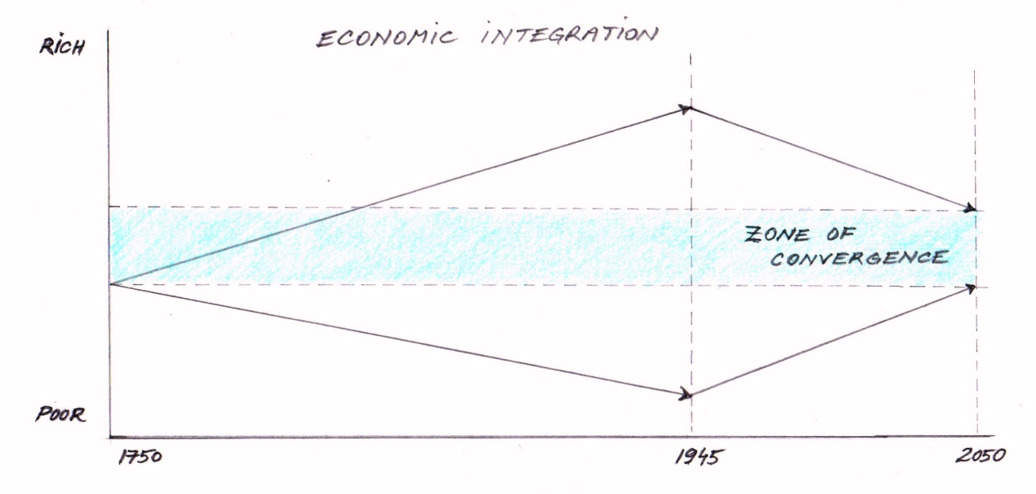
In the current context, the restitution we in the West are paying is necessary to equalize wealth to an extent sufficient to achieve global monetary convergence. Equally, the abandonment of traditional forms of social, economic and political organization by non-western countries is necessary if they are to achieve western levels of affluence, which they aspire to but know not their high costs and sacrifices.
In graphic terms this process looks like this:

Explanation: The vertical axis represents wealth and the horizontal axis represents time. Prior to the Industrial Revolution people across the world had approximately the same standard of living as agrarian societies. Western nations were first to industrialize and improve their standard of living by creating increasingly more material goods and exploiting more natural resources per capita. This led to a rift between developed and underdeveloped nations, a wealth gap that, for the sake of simplification, began to be reversed after 1945 when the UN was formed. Ever since, policy makers have sought to close the gap by reducing consumption in the West and shifting its capital, jobs and knowhow to the developing word so as to bring the latter to the same standard of development as the former. That desired standard of development is designated in the graph as the zone of convergence.

- Political centralization
To achieve political centralization, a process that is still ongoing and is by no means complete, has required divesting national assemblies of power and investing international organizations with the authority to dictate to national assemblies, which has robbed us of the right to self-determination regardless of where we are in the world. That is why democracy has been replaced with plutocracy; that is to say the rule of the people has been displaced by the rule of a dominant minority.

And yet political centralization is necessary in order to complete the transition from a world organized according to the interests of nation states to a world organized around common global interests. Without the political and institutional infrastructure to carry out this process there can be no coordinated and peaceful action and humanity will forever remain separated by artificial borders and incapable of solving the material, environmental and political problems that threaten our very existence. The reality is that the will to accomplish global unity could not have been initiated let alone coordinated by the national assemblies of the world’s 200, or thereabouts, independent nation-states. Someone had to forge ahead and the elites did.

Had we been asked to give up our hard-earned democracy for the dictates of global authorities that although consensual in their decision-making process are so limited in membership as to constitute plutocracy or UN-autocracy to the rest of us, we would have never conceded. That is why we were never asked.

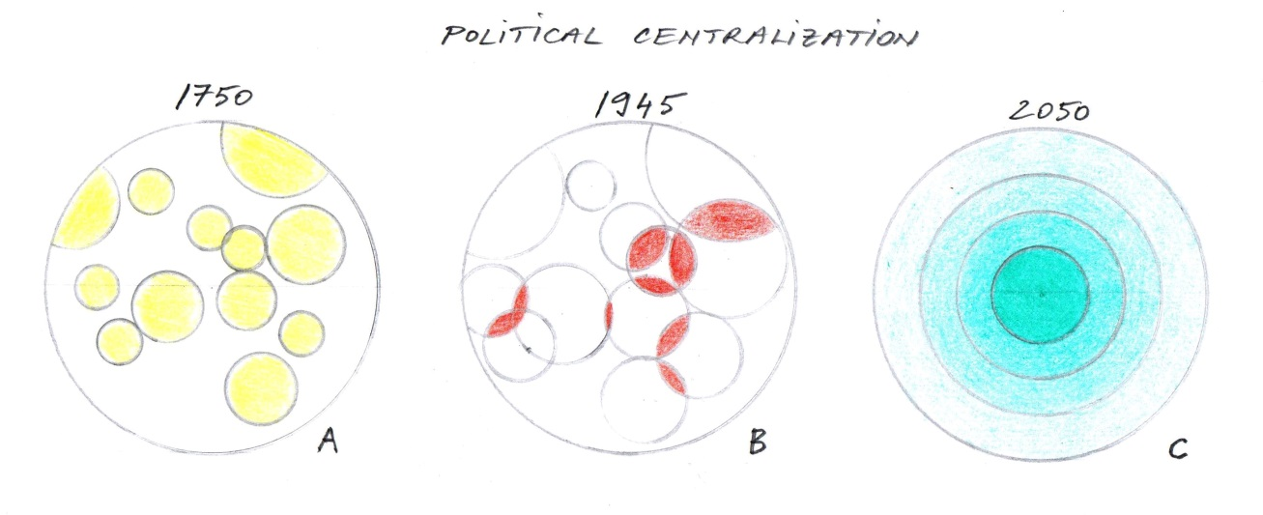
In graphic terms, this transformation looks like this:
Explanation: The concentric circles represent nations. In picture A the nations are separate entities whose territories are clearly delineated. In picture B the circles/nations are overlapping because they have outgrown their own resources and are seeking resources from outside their own borders, competing for them and causing conflict. In picture C the chaotic coexistence of separate nations has been subsumed by an orderly global structure with clearly delineated areas of jurisdiction: global, national, regional, and local, emanating from the center and expanding outward.

- Demographic limitation
To ensure that we break free from the cycle of poverty that has trapped us for millennia, that we do not exhaust the world’s resources and leave behind a world denuded for our children, and that we restore balance between nature and human civilization, has required that we undergo a brutal process of defusing the population bomb and shrinking our numbers. This process started in 1945 and is ongoing and everything, including our survival, hinges on its completion. It is euphemistically known as the ‘demographic transition’ and it is at the core of the international community and represents the obverse and hidden side of globalization.

This process requires our covert poisoning with chemical, biological and bacteriological agents that cause mass sterility and selective morbidity. This process also requires psychosocial and economic machinations to undermine the family structure so as to suppress and inhibit the formation of large families. This process has done untold damage to the genetic and intellectual endowment of mankind. This process has come to be covert and heartless because insurmountable obstacles stood in the way of legislating family size, which I explain in some detail in my book “Killing Us Softly: Causes and Consequences of the Global Depopulation Policy”.

This process requires a subtle form of infanticide as well as a subtle form of matricide and patricide. This process has prevented the birth of 2 billion people and is about to speed up the death of 3 billion people.

Had we been asked to give up our reproductive rights, downgrade the intellectual and genetic endowments of our children, and condemn our parents and ourselves to illness and premature death, we would have never agreed. That is why we were never asked.

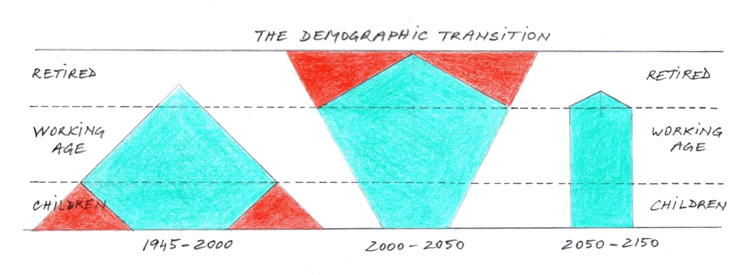
In graphic terms, the process known as the ‘demographic transition’ looks like this:
Explanation: During the first phase of the demographic transition (1945 – 2000) the onus was on reducing the total fertility rate of every country down to replacement level fertility (i.e. 2 children per woman), thus on preventing the birth of children by interfering with human fertility through covert means. During the middle stage of the demographic transition (2000-2050) the onus is on reducing the life span of the elderly who now outnumber the young in countries that have reached the middle stage of the demographic transition, the shrinking stage, and therefore constitute an unbearable burden on society because the ratio between workers and retirees is too small (c. 3 to 1), and as a result there are too few working people and too many elderly to support. The last stage of the demographic transition (2050- 2150) arrives at a lean and stable population at the end of a slow and gradual decrease in total numbers, a population that neither grows nor decreases and that is sufficiently small to live within the regenerative capacity of Mother Earth. During this stage the onslaught on the unborn and on the elderly will continue unless we take control and limit our family size voluntarily rather than allow the government to do it by covert means, as well as by working throughout our lives rather than retire early and expect to be supported by the young.
All three achievements – economic integration, political centralization and demographic limitation – are the result of conscious decisions made by policy makers not bankers. All three are largely the result of consensus not force; consensus among the elites since the masses have been excluded in order to simplify and speed up the process, but also in order to bypass democratic oversight and structural/systemic obstacles. And all three are the result of deep cooperation between professional groups that span every field of knowledge and area of competence and who have agreed to forge ahead under the cover of secrecy and by deception, knowing that it would be too difficult to talk sense into the masses since few have the intelligence to comprehend the complex issues, all lack the time necessary to study the situation, and most lack the desire to want to understand or to even want to have a role in forging the future, as most of us, let’s face it, care only for immediate gratification, for fun in the present with little consideration to the future.
There is, one could say, a split in the human race between those who only think in the present and those who think beyond the space-time continuum; between those who only think for themselves and those who also think for others and for the collective. A small fraction of humanity has acquired the intelligence to think in five dimensions whereas the rest still only master four.
But I believe we can transcend intellectual limitations with intuitive knowledge and love. No one needs to be left behind. Those who lack the smarts to understand the dilemmas of our time will make up for it with the love in their hearts. The OM Principles will see to that.
We have extraordinarily clever people at the helm and they are animated by the best intentions, but they are not gods. They do what they can with the mortal tools at their disposal; making excruciatingly difficult decisions of life and death, of poverty and wealth, of illness and good health, of sacrifices in the present for future benefits.
We are the first generation to have transcended temporal concerns. We care for people yet unborn, for species living and yet to be created, for the future and not just the present of mankind.
The power of money is used for all these ends, these noble ends, but it is conscious political decisions that guide this power.
The question is not whether the direction we are heading is good or not, since few will dispute that global peace and universal prosperity are not worthy goals and that in order to accomplish them economic integration, political centralization, and demographic limitation are indispensable prerequisites. The question is how can we achieve our common goals without being starved, discarded, sickened, and deprived of our rights and liberties by an elite that has lost touch with us and our suffering and who sees no evil, hears no evil, and speaks no evil because no evil happens to them and all evil is piled on us? That is the question.
And the answer is, by knowing. If we know we understand, if we understand we care, if we care we contribute, and if we contribute the journey will be that much easier, the pain that much more bearable, and the sacrifices that much more evenly split. If we know, we cannot be deceived and cheated, robbed and poisoned, lied to and imprisoned. If we know we would choose to live and to be governed by a different covenant, the OM (Our Mind) covenant.
We have bumbled our way through history for millennia, now we walk upright with our eyes focused on the ideals of an ideal future that we must forge from the cruelties of the present. And that we must forge together.
We are extraordinary beings capable of extraordinary things. The time has come to do the extraordinary… or perish.

Zhou Xiaochuan: Reform the International Monetary System, March 2009: http://www.pbc.gov.cn/publish/english/956/2009/20091229104425550619706/20091229104425550619706_.html

